Deep Learning Lab 1

Selvakumar G (22MAI1004)

Program 1 : Get the following input from the user: first name and last name. Write a Python program to print as

Hello first name last name   
Welcome to Python!

Code:

name = **input**("Enter your Full Name: ")

names = name.**split**(" ")

**print**(f"Hello {names[0]} {names[1]}\n Welcome to Python!")

Output:

Program 2: Assign x = 8 and y = 2. Evaluate the following expressions and write the output,   
a) x + y * 3   
b) (x + y) * 3   
c) x ** y   
d) x % y

Code:

x, y = 8, 2

**print**(f"x+y*3 = {x+y*3}\n(x+y)*3 = {(x+y)*3}\nx**y = {x**y}\nx%y = {x%y}")

Output:

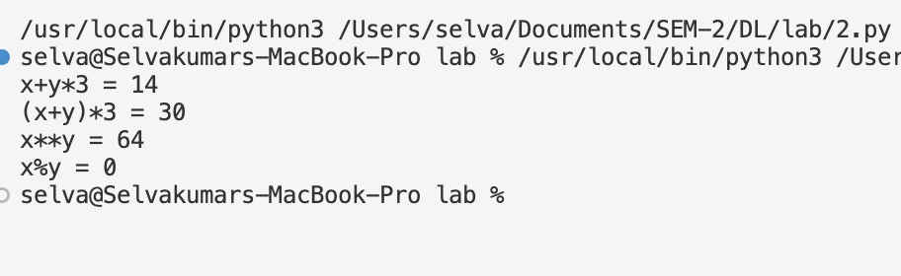

Program 3: An employee’s total weekly pay equals the hourly wage multiplied by the total   
number of regular hours plus any overtime pay. Overtime pay equals the total   
overtime hours multiplied by 1.5 times the hourly wage. Write a program that takes as   
inputs the hourly wage, total regular hours, and total overtime hours and displays an   
employee’s total weekly pay.

Code:

hourly_wage = **float**(**input**("Enter the Hourly Wage of the Employ: "))

total_regular_hours = **float**(**input**("Enter the total regular Hours: "))

total_overtime_hours = **float**(**input**("Enter the total overtime Hours: "))

overtime_pay = total_overtime_hours * (1.5 * hourly_wage)

total_weekly_pay = hourly_wage * total_regular_hours + overtime_pay

**print**(total_weekly_pay)

Output:

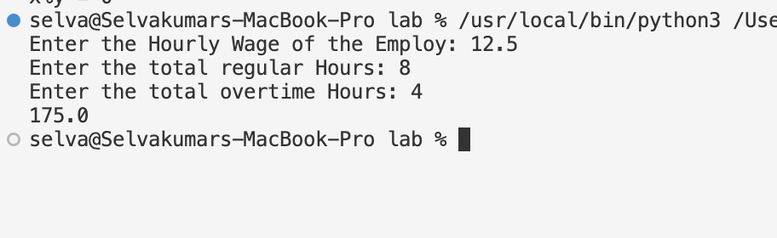

Problem 4: A company decides to give bonus to all its employees for Diwali. A 5% bonus on salary is given to the male workers and 15% bonus on salary to the female workers. If the salary of the employee is less than Rs. 10000/- then the employee gets an extra 2% bonus on salary. Calculate the bonus that the employee will get and display the total salary.

Code:

gender = **input**("Enter the Employee Gender (M for Male, F for Female) : ")

salary = **int**(**input**("Enter the Employee Salary"))

total_salary = salary

if salary < 10000:

bonus = salary * 0.02

total_salary += bonus

if gender == 'm':

bonus = salary * 0.05

total_salary += bonus

elif gender == "f":

bonus = salary * 0.15

total_salary += bonus

**print**(bonus)

**print**(total_salary)

Output:

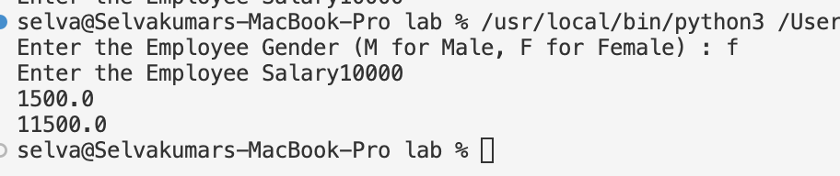

Problem 5: Write a series of Python statements that will read three strings from the user, and then print them in dictionary order. (Note: you can compare two strings using the relational operators).

Code:

str1 = **input**("Enter a string: ")

str2 = **input**("Enter a string: ")

str3 = **input**("Enter a string: ")

if str1 < str2 and str1 < str3:

if str2 < str3:

**print**(str1, str2, str3)

else:

**print**(str1, str3, str2)

elif str2 < str1 and str2 < str3:

if str1 < str3:

**print**(str2, str1, str3)

else:

**print**(str2, str3, str1)

else:

if str1 < str2:

**print**(str3, str1, str2)

else:

**print**(str3, str2, str1)

Output:

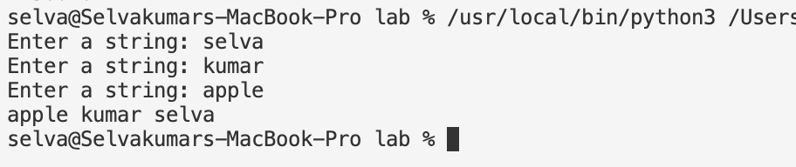

Program 6: Write a program that takes user’s name and PAN card number. Validate the information using string functions

Code:

name = **input**("Enter the user name: ")

pan_no = **input**("Enter the PAN number: ")

**print**("Checking whether the name is valid: ", name.**isalpha**())

**print**("Checking whether the PAN number is valid: ", pan_no.**isalnum**())

Output:

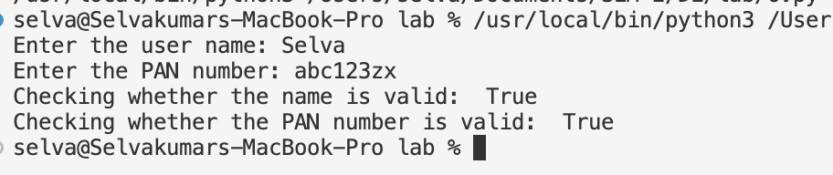

Program 7: Write a Python program to parse an email id to print from which email server it was sent.

Code:

mail = **input**("Enter the Mail Id: ")

**print**(mail.**split**("@")[1])

Output:

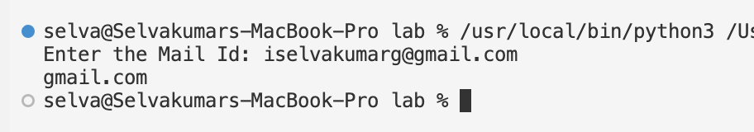

Program 8: Write a Python program to strip a set of characters from a string Encrypt a given message by “rotating” each letter by a fixed number of places. To rotate a letter means to shift it through the alphabet, wrapping around to the beginning if necessary, so ‘A’ rotated by 3 is ‘D’ and ‘Z’ rotated by 1 is ‘A’. Write a function called rotate_word that takes a string and an integer as parameters, and returns a new string that contains the letters from the original string rotated by the given amount. E.g Given String: HAL Encrypted String: JCN (Rotated by 2)

Code: